**Introduction**

We were asked to build a binary circuit. The circuit must be able to detect an input from a motion sensor and a switch. When either the motion sensor senses a movement, or the switch is turned on, the light will be turned on. When the switch is on and the motion sensor senses movement, not only the light will be turned on, but the alarm will also sound.

We utilized a breadboard equipment branded E&L Instruments C.A.D.E.T IITM. The equipment consisted of features that are feasible for the necessity of this lab project, including, but not limited to, 8 LED pairs, 8 logic switches, frequency rotary switch.

**Prelab circuit designs**

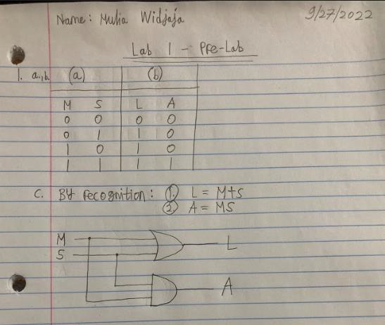

Figure 1. Mulia Widjaja’s truth table and logic gate from the prelab

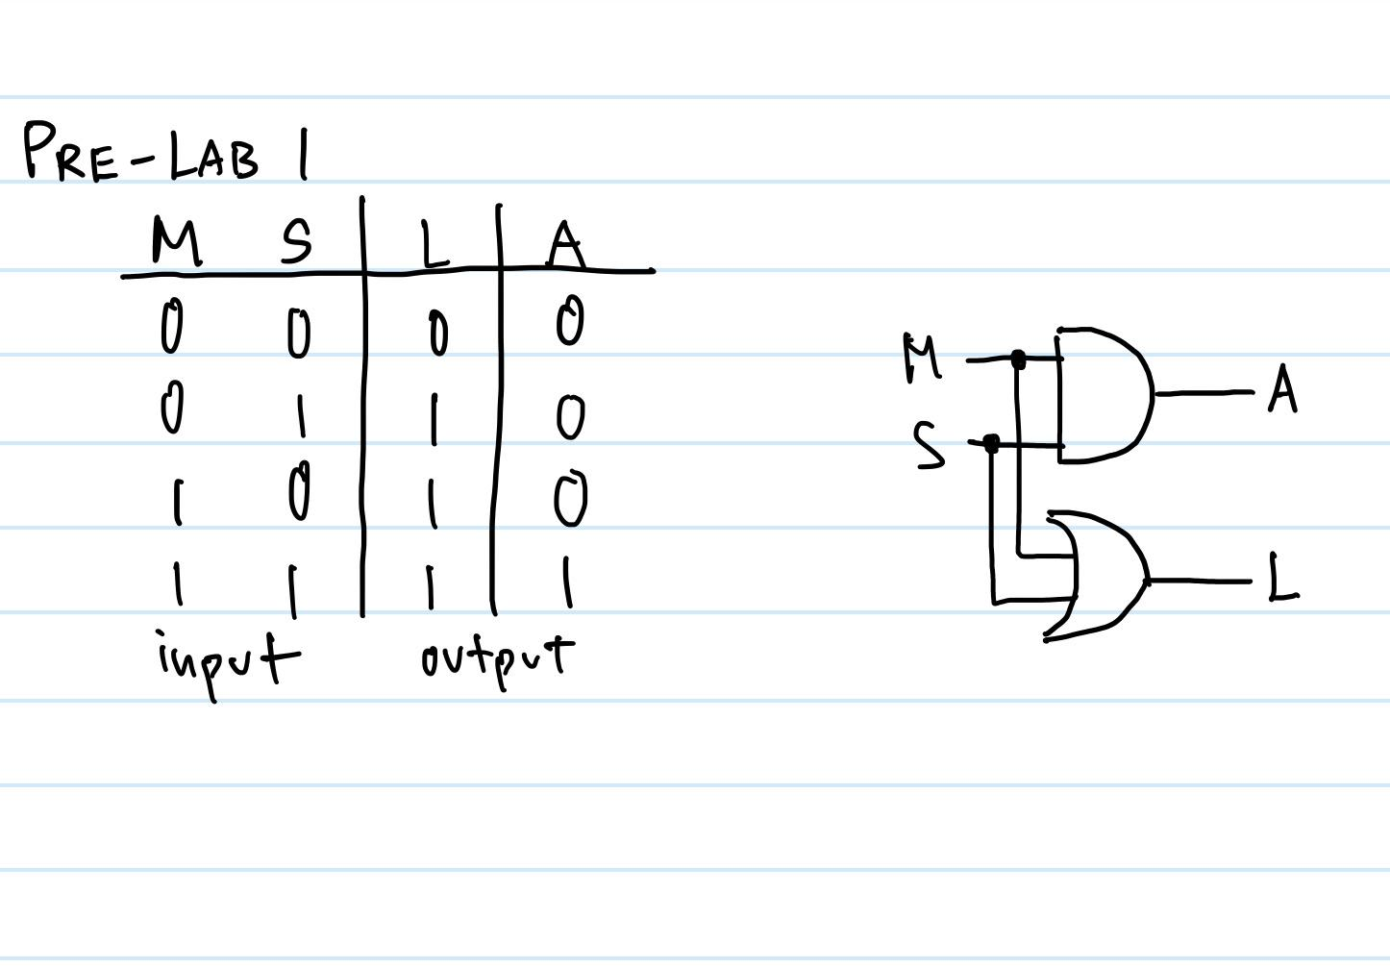

Figure 2. Yi Qian Goh’s truth table and logic gate from the prelab

**Answers to Part 1 of the lab procedure**

We tested those necessary features and took notes of important key takeaways and analyses. First, we began by testing 8 pairs of LEDs on the breadboard. We initialized set up for linking those LEDs to the power source. Based on our two observations, the voltage level of +5V causes the red LEDs to be connected internally. Also, the ground (GND) level causes the green LEDs to be connected internally.

Second, we tested S1 and LED 1 by connected them. When the switch is down the green LED 1 lights up, and when the switch is up the Red LED 1 lights up. We then connected S2 to S8 and LED 2 to LED 8, respectively. For all respective switches and LEDs, when the switch moved down, the respective Red LEDs turned on, while the upward switch caused the respective Green LEDs to turn on.

Third, we made a connection and adjusted the top frequency rotary switch for the function generator. The adjustment was implemented due to the instructions for observing the alternating on and off between Red and Green LEDs. We decided to focus on counting the number of times the Red LED blinked for 30 seconds when the knob was set to '1'. As it turned out, the number of Red flashed about 56 times in that time interval.

When the rotary dial was turned to '10', both the red and green lights blink faster compared to when the dial was at 1. By the time we reach '100' in the rotary dial, it was blinking very rapidly to the point where our eyes could observe it no longer. At 100K, the LEDs on each side of red and green LED4 light up. The red LED2 also lights up dimly. Pulse Width Modulation is spreading due to high frequency.

**Part 3 logic circuit procedure, construction, and testing**

We began with the bread board set up from Part 2 of this lab. On the breadboard we had three different integrated circuit (IC) chips: the 74x04, 74x08, and the 74x32. Respectively, each of the IC chips represented inverter (NOT) logic gates, AND logic gates, and OR logic gates. However, for the logic circuit in part 3 we only need the AND and OR IC chips. So, after removing the unused inverter logic gate chip we used multiple jump wires to create a circuit and connect the LEDs, motion sensor, switch, and the alarm according to our schematics drawn for our prelab assignment (figure 1 and 2). As for the AND logic gates, we connected Pin 1 and Pin 2 for our factors (value to be passed to the AND gates) and Pin 3 for our products (value after being passed through the AND gates). Similarly, as for the OR logic gates, we connected Pin 1 and Pin 2 for our addends (value to be passed to the OR gates) and Pin 3 for our sum (value after being passed through the OR gates).

At first, we had issues with the alarm not making any sound when it should. To debug this error, we connected the motion sensor to the LEDs. This way, when the motion sensor senses movement the LED will turn on. The LED did turn on which means the motion sensor was working properly. After swapping the sensors and alarms multiple times, the entire circuit worked properly when we used a slightly larger alarm. The issue all along was not our jump wire connection, but it was because the alarm was not working properly. We attempted to utilize a slightly larger alarm, and the circuit worked as expected.

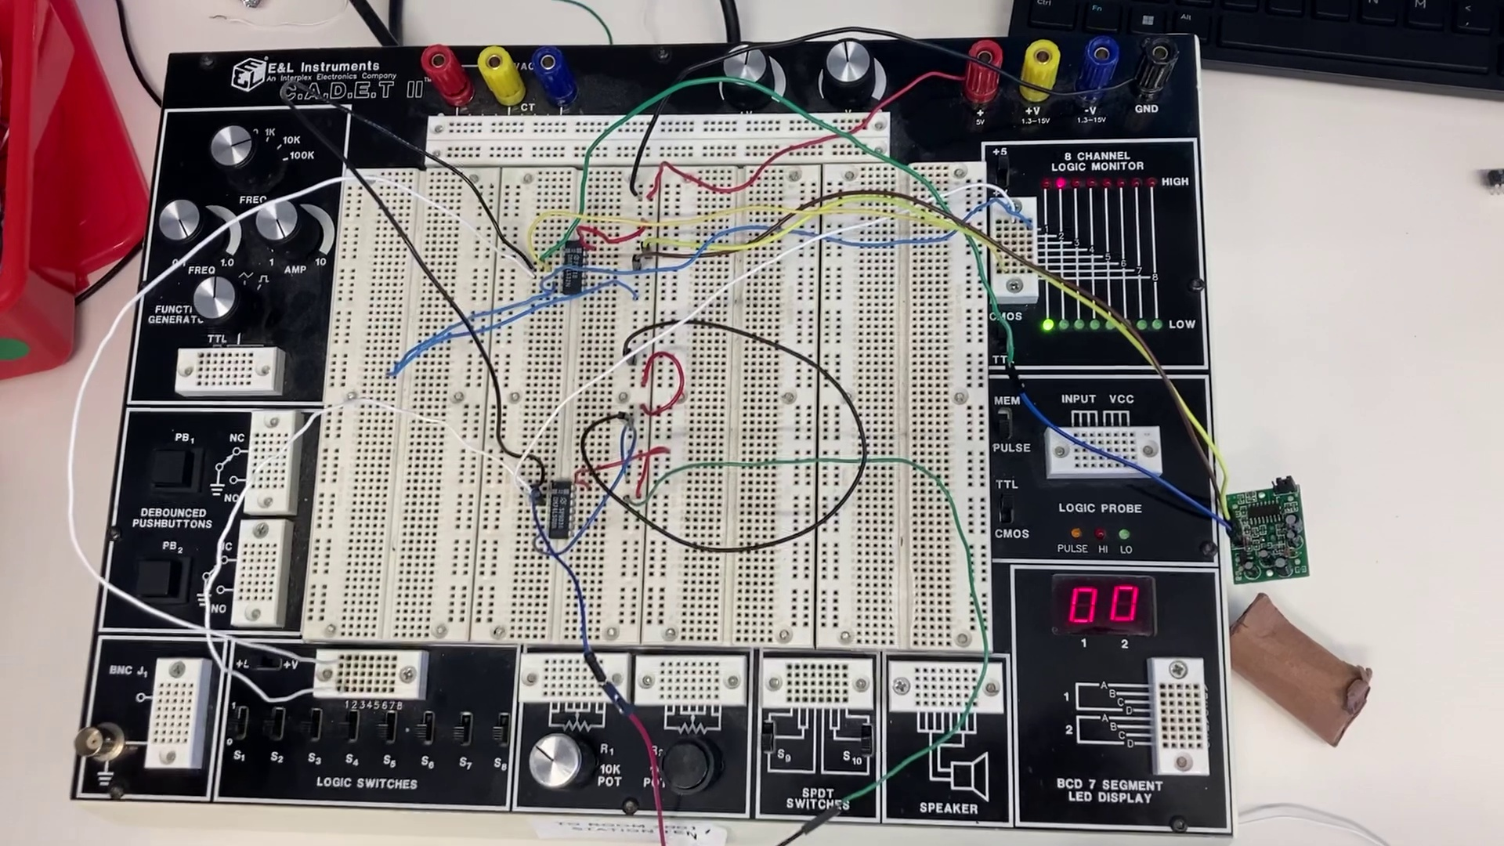

Figure 3: Our circuits connected using AND and OR gates represented by IC

**Other lab questions/answers**

1. Suppose the alarm system is functioning in such a way that the alarm (A) is activated as soon as motion is detected. List the possible issues with this system and how could you determine if the system is acting incorrectly.

The alarm might be connected to the output end of the OR logic gate IC chip. So instead of the light solely turning on when motion is detected, the alarm is activated as well.

1. Suppose the alarm system is operating in such a way that the alarm (A) goes on continuously regardless of the state of the other inputs. List the possible issues with this system and how you could fix this issue.

This means the alarm is directly connected from the power source to the ground. To fix this, one must look at where the positive end of the alarm was being connected to. It should be linked to the output end of one of the logic gates in order for the system of logic gates to work.